**Design Documentation**

**By:**

**Net 1 Bier**

**Randolph Bock 25905570**

**FJ Fourie 26047799**

Supervisor: Prof J. Holm

Potchefstroom

2017

**Contents**

5 Design Documentation: 1

5.1 System Design Documaentation 1

5.1.1 Final System Functional Definition: 1

5.1.2 System concept drawings: 2

5.1.3 System interface Definitions: 4

5.1.4 System integration testing: 8

5.2 Sub-system Design Documentation Randolph Bock: 9

5.2.1 Technology Survey/Datasheets 9

5.2.2 Application Notes 17

5.2.3 Trade off Studies 19

5.2.4 Design Drawings: 20

5.2.5 Behavioural Modelling: 21

5.2.6 Design implementation: 23

5.2.7 Sub-system Test and Evaluation: 24

5.3 Sub-system Design Documentation FJ Fourie: 25

5.3.1 Technology Survey/Datasheets 25

5.3.2 Application Notes 26

5.3.3 Trade off Studies 26

5.2.4 Design Drawings: 27

5.2.5 Behavioural Modelling: 29

5.2.6 Design implementation: 29

5.2.7 Sub-system Test and Evaluation: 32

**List of Figures:**

Figure 1: Final System Functional Definition 1

Figure 2: Concept Design No.1 2

Figure 3: Concept Design No.2 3

Figure 4: Final Alarm Panel Design 20

Figure 5: Alarm Panel Finite State Machine 21

Figure 6: Alarm Panel Flow Diagram 22

Figure 7: Alarm Panel Final Construction 23

Figure 8: Alarm Panel Final Construction (Inside) 23

Figure 9: Back end initial screen concept 27

Figure 10: Admin login screen concept 28

Figure 11: Incident display screen concept 28

Figure 12: Back end initial screen 30

Figure 13: Admin login screen 30

Figure 14: Incident display screen 31

**List of Tables:**

Table 1: Interface Definitions 4

Table 2: Payload Fields 7

Table 3: System Integration testing 8

Table 4: Alarm Panel Development Testing 24

Table 5: Alarm Panel Implementation Testing 25

Table 6: Back-end Testing 32

**List of abbreviations:**

* FSM – Finite State Machine
* UDP – User Datagram Protocol
* OS – Operating System
* SoC – System on Chip
* SBC – Single Board Computer.
* DCS – Door Contact Switch

# 5 Design Documentation:

## 5.1 System Design Documaentation

### 5.1.1 Final System Functional Definition:

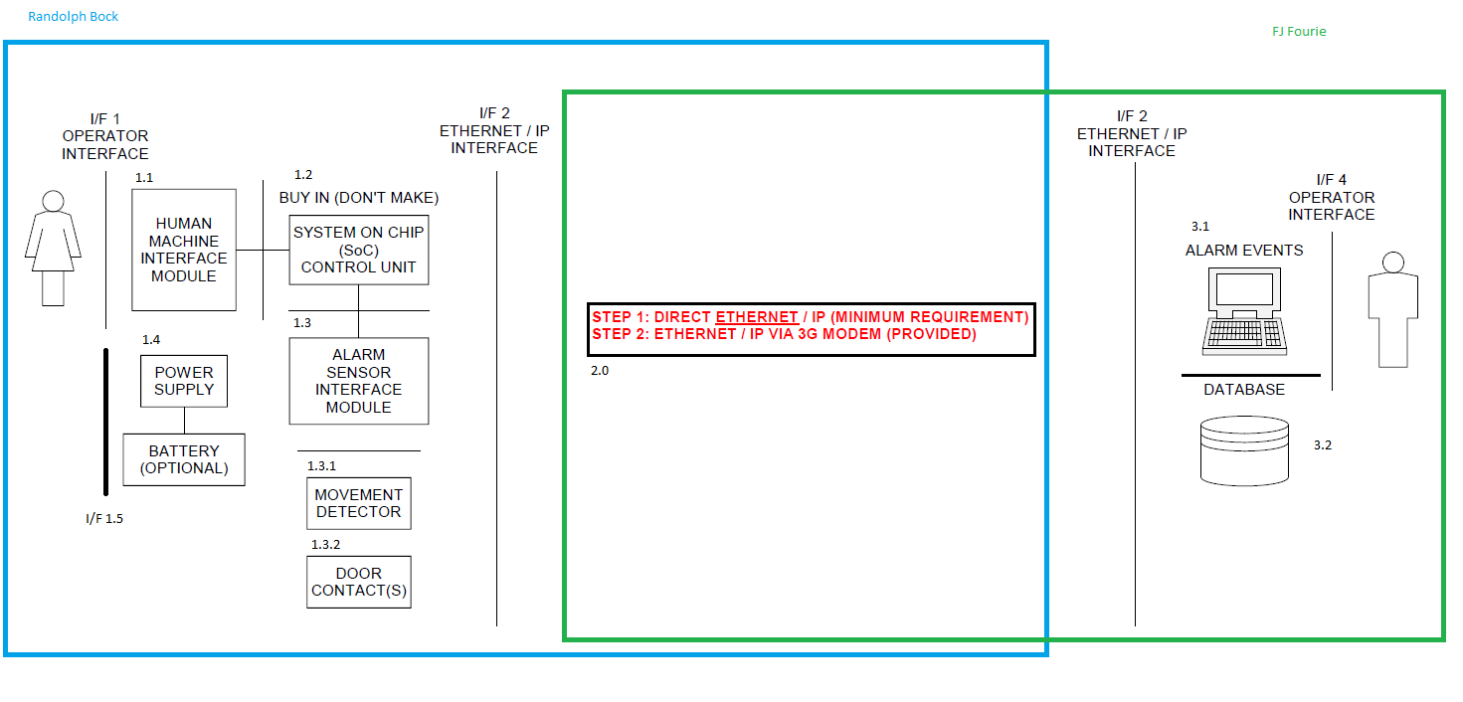

Figure : Final System Functional Definition

* Unit 1 and Part of unit 2 (I/F 2 on the Alarm panel side) allocated to Randolph Bock
* Unit 3 and Part of unit 2 (I/F 2 on Backend program side) allocated to FJ Fourie

I/F 2 – Network interaction is described in Interface control document (I/F 2).

### 5.1.2 System concept drawings:

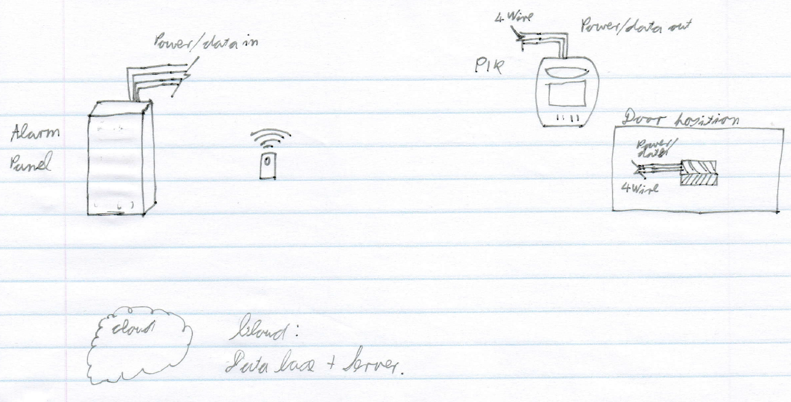

Figure : Concept Design No.1

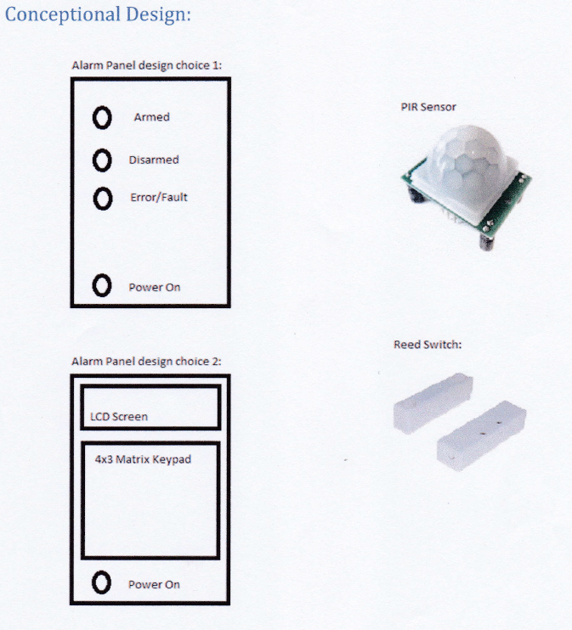

Figure : Concept Design No.2

### 5.1.3 System interface Definitions:

Table : Interface Definitions

|  |  |  |
| --- | --- | --- |
| Interface number | Type | Definitions |
| I/F 1.1 | Human/Machine | Visual and audio interface with the user to show the state of the system. As well as a Matrix keypad as an input to the system for the user. |
| I/F 1.2 | System/Electronics | Contains the connections from the matrix keypad to the SoC, also contains the driver circuits for the LED’s, buzzer and siren. |
| I/F 1.3 | System/Electronics | Contains the input circuitry for sensor inputs from door contacts and PIR sensors, to be managed safely to the SoC. |
| I/F 1.4 | Electronic | Connection via 2core or 4 core insulated wires to the sensors. |
| I/F 1.5 | Electronic | The mechanical interface will be a two-point screw terminal for both sides so that a wire can be connected between the two. |
| I/F 2 | Network | TCP connection form the Alarm panel to the Backend program. Along with data protocol described in interface control document (I/F 2) |
| I/F 3.1 | Computer | This is the interface between the backend program and the clod server |
| I/F 3.2 | Computer | This is the interface between the cloud server and the database |
| I/F 4.1 | Electronic/ Computer | This is the interface between the backend program the operator |
| I/F 5.1 | Electronic/ Computer | This is the interface between the back-end program and the cellular network. |

**Interface control document (I/F 1.5)**

This interface control document is the interaction between the power block and the alarm.

I/F 1.5

Power block

Alarm Panel

**Electrical requirements**

The power block will provide 12 V and 6 W power to the alarm panel.

**Mechanical requirements:**

The mechanical interface will be a two-point screw terminal for both sides so that a wire can be connected between the two.

This document was signed in Potchefstroom on the date 2017/09/4 as an agreement between the EERI327/ INEM327 and REII327 students regarding the power supply to the alarm panel. This document is binding until the end of the 3rd year design module 2017.

Representatives

_________________________________

**C.F. Greyling**

_________________________________

**FJ Fourie**

Witnesses

_____________________________

**Witness 1**



_________________________________

**Witness 2**

**Interface control document (I/F 2):**

This interface control document is the network interaction between the Alarm panel and the Back-end security software.

**Network requirements:**

Transmission Control Protocol, TCP, to be used to send data from Panel to backend services.

**For network connection:**

1. The Alarm panel will send out a broadcast command over User Datagram Protocol, UDP. (Port 7000)
2. The Back-end server will then send it’s IP over UDP to the alarm panel
3. A TCP Connection will be set-up between the server and the alarm panel. (Port 7000)
4. Communications will then take place according to the protocol requirements below

Protocol requirements:

Protocol payload fields:

Table : Payload Fields

|  |  |  |  |  |
| --- | --- | --- | --- | --- |
| Protocol ID (‘1B’) | Section code | Date | Time | Client ID |

The payload fields will be “#” separated.

### 5.1.4 System integration testing:

Testing done in an electronics lab, where the alarm panel was power with an external power supply delivering 12V 0.5Amps of power.

A wireless Router was used as a Network point. The Backend software and server was hosted on a Laptop. Both the Laptop and the Alarm Panel connects to the Wireless router.

Another Laptop is used to remotely connect to the alarm panel to monitor all aspects of the Alarm panel while in use.

Table : System Integration testing

|  |  |  |
| --- | --- | --- |
| Action | Expected Results | ✓/🗶 |
| UDP Message sent from Alarm to Backend | UDP Message received on backend program | ✓ |
| TCP Message sent from Alarm to Backend | TCP Message received on backend program | ✓ |
| Trigger Alarm | Correct Message sent from Alarm through network with TCP to PC | ✓ |
| Read from Database | Read specific data from database to PC | ✓ |

## 5.2 Sub-system Design Documentation Randolph Bock:

### 5.2.1 Technology Survey/Datasheets

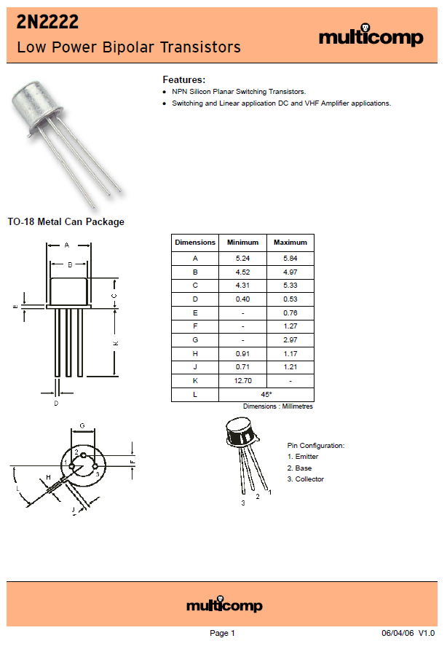

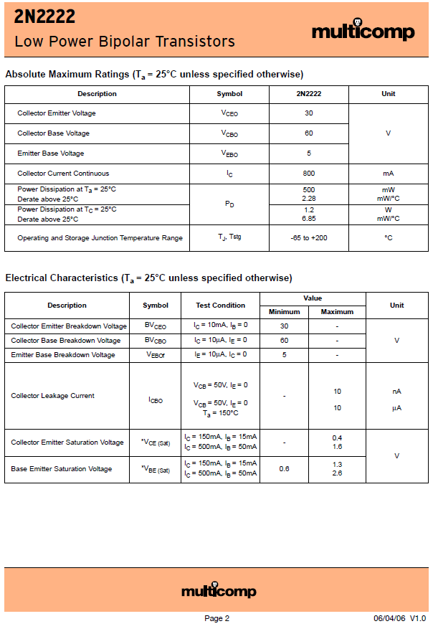

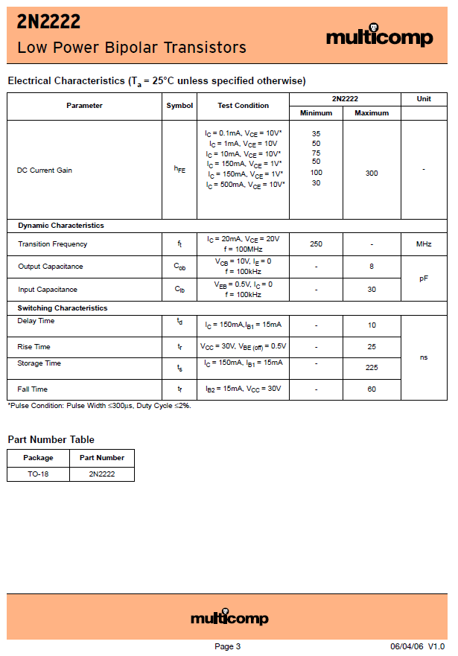

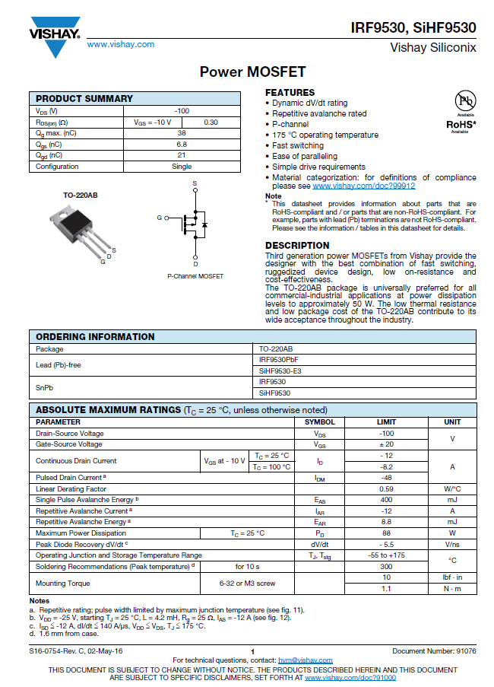

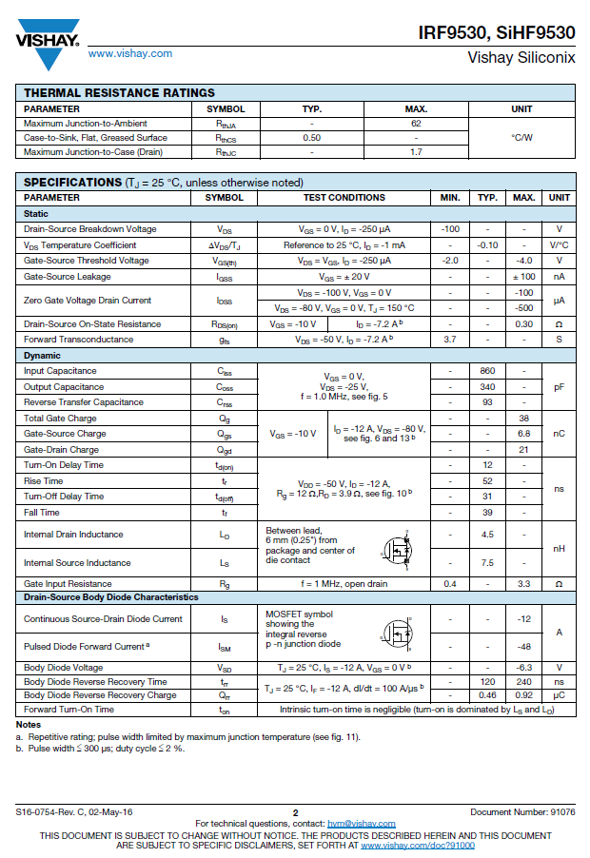

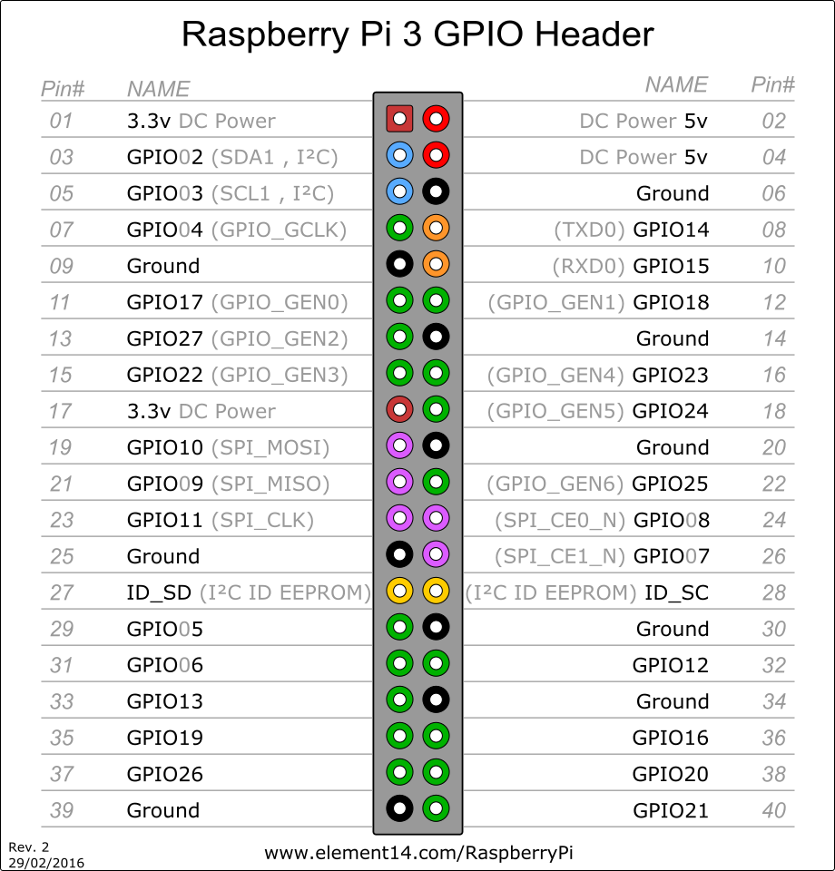

[1]

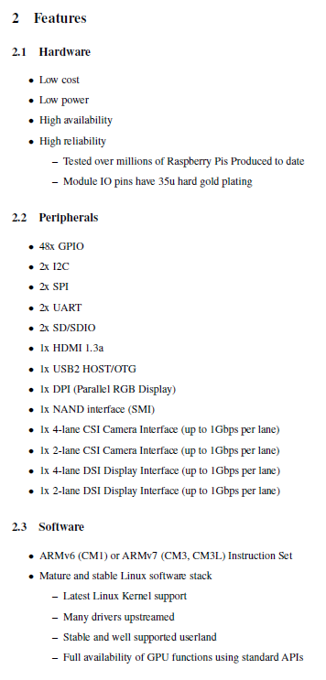

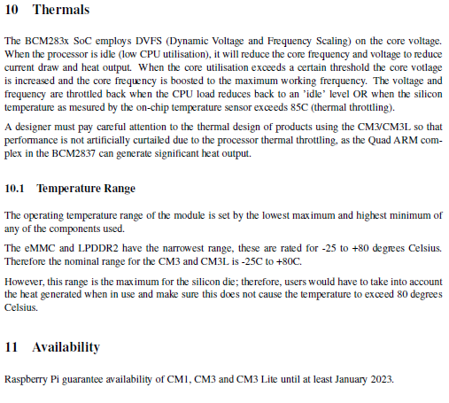

[2]

### 5.2.2 Application Notes

**GPIO Pins of the Raspberry Pi:**

GPIO pins can be configured as either general-purpose input, general-purpose output or as one of up to 6 special alternate settings, the functions of which are pin-dependant.

There are 3 GPIO banks on BCM2835.

Each of the 3 banks has its own VDD input pin. On Raspberry Pi, all GPIO banks are supplied from 3.3V. **Connection of a GPIO to a voltage higher than 3.3V will likely destroy the GPIO block within the SoC.**

A selection of pins from Bank 0 is available on the P1 header on Raspberry Pi.

GPIO Pads

The GPIO connections on the BCM2835 package are sometimes referred to in the peripherals datasheet as "pads" - a semiconductor design term meaning "chip connection to outside world".

The pads are configurable CMOS push-pull output drivers/input buffers. Register-based control settings are available for

* Internal pull-up / pull-down enable/disable
* Output [drive strength](http://www.scribd.com/doc/101830961/GPIO-Pads-Control2)
* Input Schmitt-trigger filtering

Power-On States

All GPIOs revert to general-purpose inputs on power-on reset. The default pull states are also applied, which are detailed in the alternate function table in the ARM peripherals datasheet. Most GPIOs have a default pull applied.

Interrupts

Each GPIO pin, when configured as a general-purpose input, can be configured as an interrupt source to the ARM. Several interrupt generation sources are configurable:

* Level-sensitive (high/low)
* Rising/falling edge
* Asynchronous rising/falling edge

Level interrupts maintain the interrupt status until the level has been cleared by system software (e.g. by servicing the attached peripheral generating the interrupt).

The normal rising/falling edge detection has a small amount of synchronisation built into the detection. At the system clock frequency, the pin is sampled with the criteria for generation of an interrupt being a stable transition within a 3-cycle window, i.e. a record of "1 0 0" or "0 1 1". Asynchronous detection bypasses this synchronisation to enable the detection of very narrow events.

Alternative Functions

Almost all the GPIO pins have alternative functions. Peripheral blocks internal to BCM2835 can be selected to appear on one or more of a set of GPIO pins, for example the I2C busses can be configured to at least 3 separate locations. Pad control, such as drive strength or Schmitt filtering, still applies when the pin is configured as an alternate function.

[3]

**Raspberry Pi Power:**

Typically, the model B uses between 700-1000mA depending on what peripherals are connected; the model A can use as little as 500mA with no peripherals attached. The maximum power the Raspberry Pi can use is 1 Amp.

The power requirements of the Raspberry Pi increase as you make use of the various interfaces on the Raspberry Pi. The GPIO pins can draw 50mA safely, distributed across all the pins; an individual GPIO pin can only safely draw 16mA. The HDMI port uses 50mA, the camera module requires 250mA, and keyboards and mice can take as little as 100mA or over 1000mA!

[4]

**Python Functions:**

Defining a Function

You can define functions to provide the required functionality. Here are simple rules to define a function in Python.

Function blocks begin with the keyword **def** followed by the function name and parentheses ( ( ) ).

Any input parameters or arguments should be placed within these parentheses. You can also define parameters inside these parentheses.

The first statement of a function can be an optional statement - the documentation string of the function or *docstring*.

The code block within every function starts with a colon (:) and is indented.

The statement return [expression] exits a function, optionally passing back an expression to the caller. A return statement with no arguments is the same as return None.

[5]

Python Error handling:

What is Exception?

An exception is an event, which occurs during the execution of a program that disrupts the normal flow of the program's instructions. In general, when a Python script encounters a situation that it cannot cope with, it raises an exception. An exception is a Python object that represents an error.

When a Python script raises an exception, it must either handle the exception immediately otherwise it terminates and quits.

Handling an exception

If you have some suspicious code that may raise an exception, you can defend your program by placing the suspicious code in a try: block. After the try: block, include an except: statement, followed by a block of code which handles the problem as elegantly as possible.

[6]

### 5.2.3 Trade off Studies

|  |  |  |  |  |  |
| --- | --- | --- | --- | --- | --- |
| **Visual Human Machine interface (I/F 1):** | | | |  |  |
|  | **LCD Screen** | **LED's** | **7-Segment** |  | **Weight** |
| **Cost** | 3 | 10 | 7 |  | 0,5 |
| **Reliability** | 6 | 9 | 7 |  | 0,3 |
| **Ease of use** | 6 | 7 | 6 |  | 0,2 |
|  | 4,5 | 9,1 | 6,8 |  |  |
|  |  |  |  |  |  |
| **Input Human Machine interface (I/F 1):** | | | |  |  |
|  | **Remote** | **Turn key** | **Keypad** |  | **Weight** |
| **Cost** | 1 | 5 | 9 |  | 0,5 |
| **Reliability** | 2 | 2 | 8 |  | 0,3 |
| **Ease of use** | 7 | 9 | 6 |  | 0,2 |
|  | 2,5 | 4,9 | 8,1 |  |  |
|  |  |  |  |  |  |
| **5V Voltage regulator** | |  |  |  |  |
|  | **LM7805** | **LM371** | **usb1002** |  | **Weight** |
| **Efficiency** | 3 | 4 | 8 |  | 0,5 |
| **Cost** | 8 | 8 | 7 |  | 0,2 |
| **Reliability** | 7 | 8 | 9 |  | 0,3 |
|  | 5,2 | 6 | 8,1 |  |  |

### 5.2.4 Design Drawings:

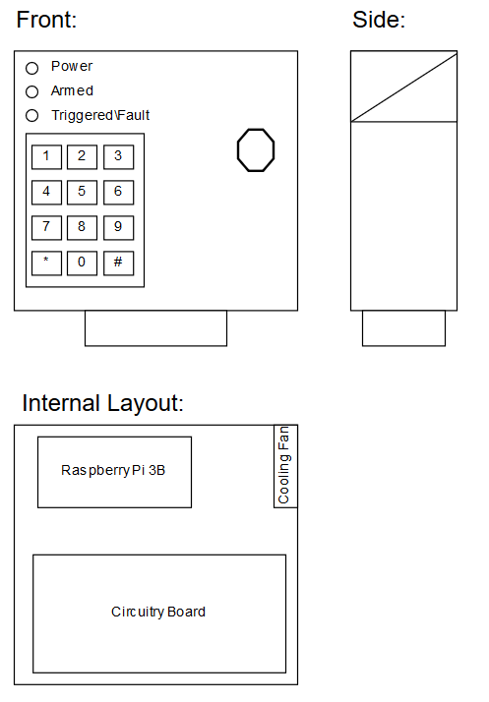

Figure : Final Alarm Panel Design

### 5.2.5 Behavioural Modelling:

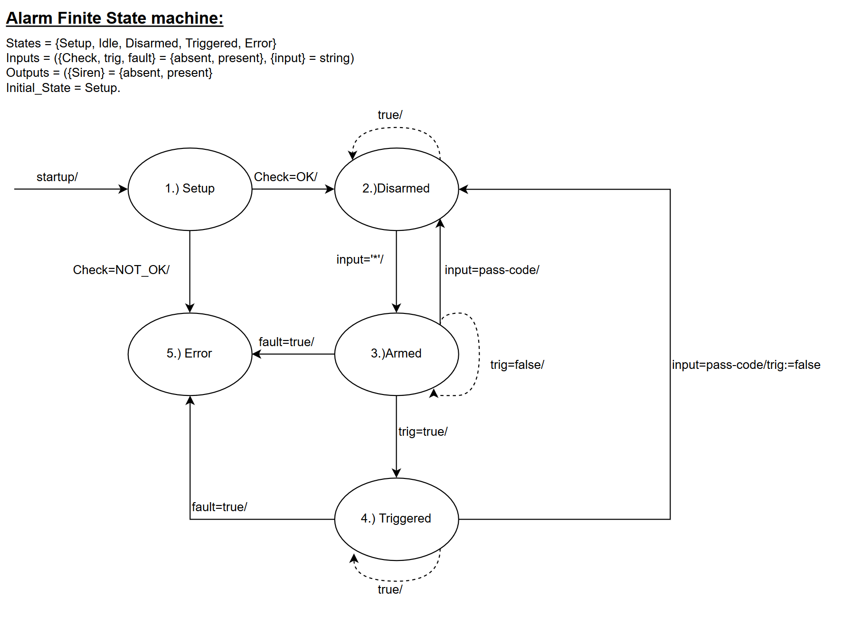

Figure : Alarm Panel Finite State Machine

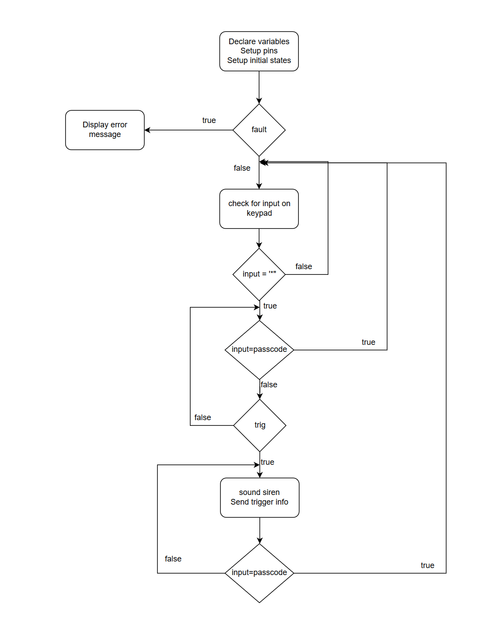

Figure : Alarm Panel Flow Diagram

### 5.2.6 Design implementation:

Final construction of Alarm Panel:

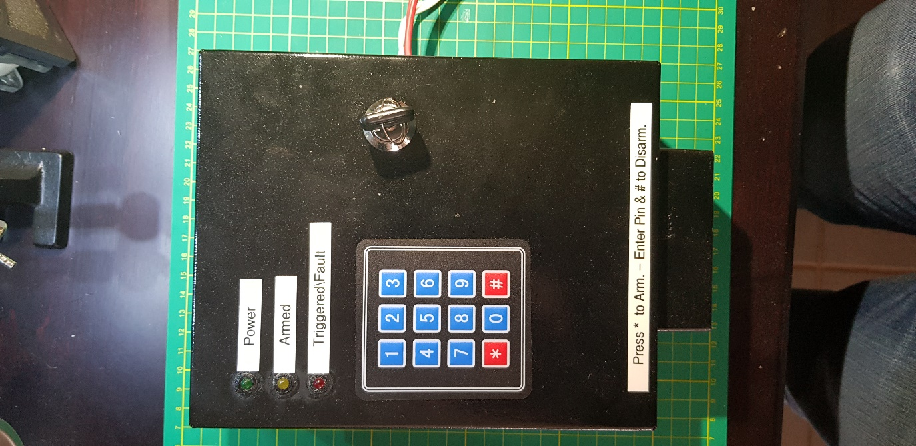

Figure : Alarm Panel Final Construction

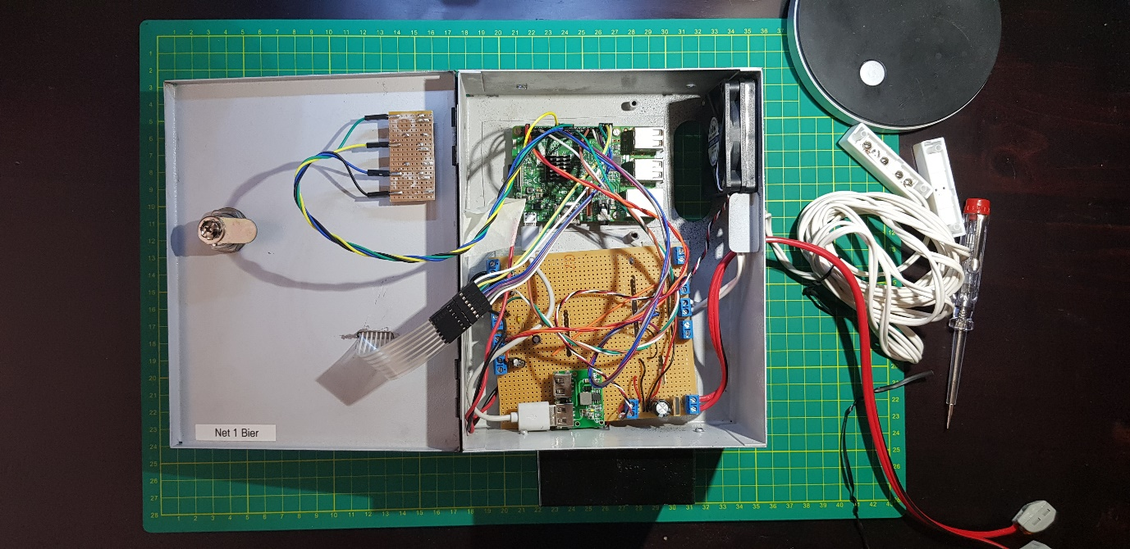

Figure : Alarm Panel Final Construction (Inside)

### 5.2.7 Sub-system Test and Evaluation:

Table : Alarm Panel Development Testing

|  |  |  |
| --- | --- | --- |
| Action | Expected Results | ✓/🗶 |
| Program started | Terminal shows program has started and heartbeat signal is shown on the power status LED | ✓ |
| Buttons are Pressed on the Keypad | Terminal shows the button pressed | ✓ |
| The “*” button is pressed in idle mode to enter armed Mode | The terminal displays that the system is arming, when the system is armed the terminal will display armed, and a heartbeat signal will show on the Armed status LED | ✓ |
| Moving the reed switch while in armed mode | The siren starts ringing. The terminal displays a trigger on the Reed sensor. The Triggered status LED starts flashing | ✓ |
| Moving the PIR sensor while in armed mode | The siren starts ringing. The terminal displays a trigger on the PIR sensor. The Triggered status LED starts flashing | ✓ |

Table : Alarm Panel Implementation Testing

|  |  |  |
| --- | --- | --- |
| Action | Expected Results | ✓/🗶 |
| Power up | The system run through the setup phase and the heartbeat signal is shown on the power status LED. The system is then in the idle state. | ✓ |
| The “*” button is pressed in idle mode to enter armed Mode | A buzzer will start sounding and after 5 second the system will enter the armed state. A heartbeat signal will show on the Armed status LED | ✓ |
| Moving the reed switch (DCS) while in armed mode | The Triggered status LED starts flashing. The user is then given time to disarm the system. After the time has elapsed (20 seconds) and no passcode has been entered or the incorrect passcode has been entered. The siren starts ringing. A UDP message is sent showing a Door switch trigger has occurred | ✓ |
| Disarming the system when the Reed Switch (DCS) has been triggered | The system turns of the armed status LED, and the Triggered status LED. Thereafter the system returns to the idle state | ✓ |
| Triggering the PIR sensor while in armed mode | The siren starts ringing. The Triggered status LED starts flashing. A UDP message is sent showing a PIR sensor trigger has occurred | ✓ |
| Enter the passcode + “#” while in armed state | The system turns of the armed status LED and returns to the idle state | ✓ |
| Enter the passcode + “#” while in triggered state | The system turns of the triggered status LED and returns to the idle state | ✓ |

## 5.3 Sub-system Design Documentation FJ Fourie:

### 5.3.1 Technology Survey/Datasheets

Datasheets in separate PDF

### 5.3.2 Application Notes

Application notes in separate PDF

### 5.3.3 Trade off Studies

|  |  |  |  |  |  |
| --- | --- | --- | --- | --- | --- |
| **Programming Language** | | | |  |  |
|  | **QT** | **IDLE** | **Matlab** |  | **Weight** |
| **Ease of use** | 8 | 6 | 7 |  | 0,2 |
| **Available information** | 8 | 9 | 10 |  | 0,3 |
| **Functionality** | 10 | 7 | 8 |  | 0,5 |
|  | 9 | 7,4 | 8,9 |  |  |
|  |  |  |  |  |  |
| **Database program bundles** | | | |  |  |
|  | **Oracle Database** | **XAMPP** | **MYSQL** |  | **Weight** |
| **Ease of use** | 7 | 10 | 9 |  | 0,2 |
| **Available information** | 6 | 8 | 9 |  | 0,3 |
| **Functionality** | 8 | 9 | 10 |  | 0,5 |
|  | 7,2 | 8,9 | 9,5 |  |  |

### 5.2.4 Design Drawings:

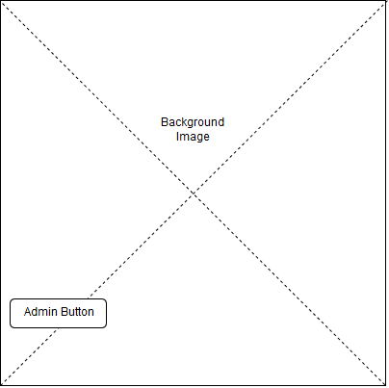

Figure : Back end initial screen concept

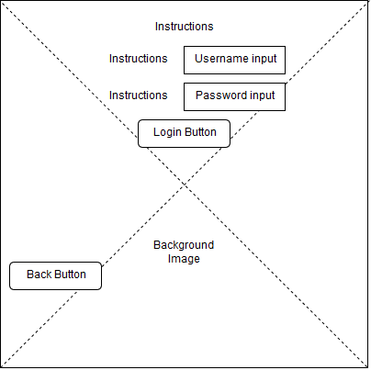

Figure : Admin login screen concept

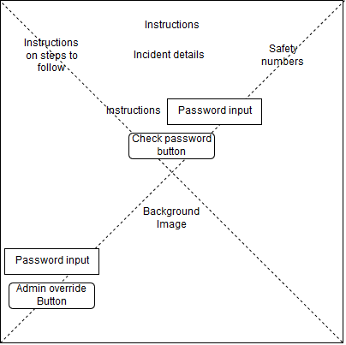

Figure : Incident display screen concept

### 5.2.5 Behavioural Modelling:

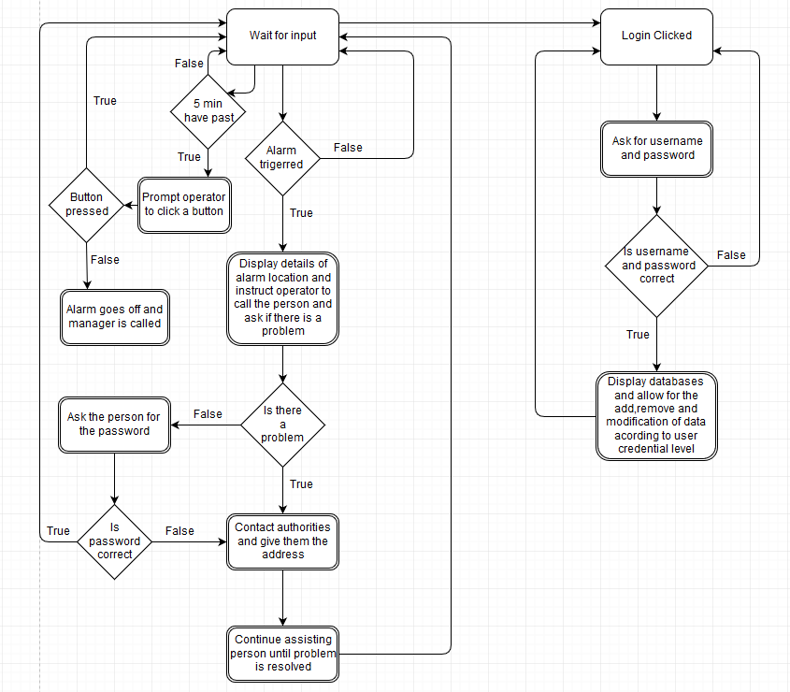

### 5.2.6 Design implementation:

Screenshots from backend program that has been made from the design drawings above.

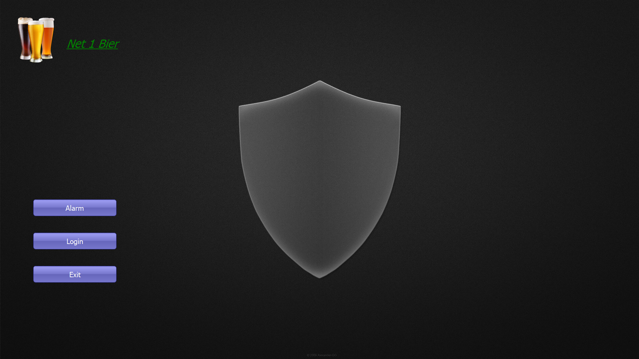

Figure : Back end initial screen

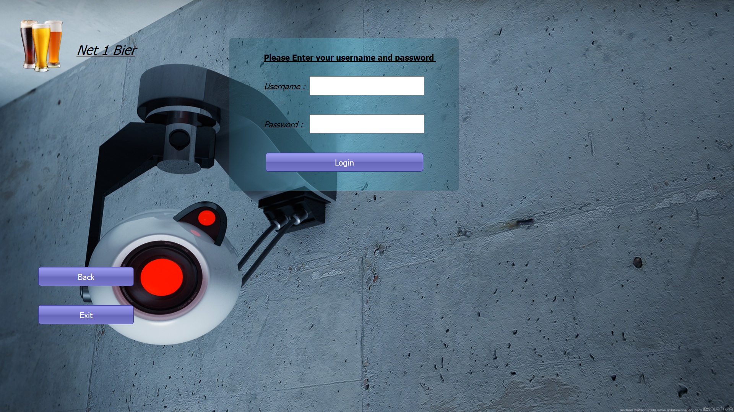

Figure : Admin login screen

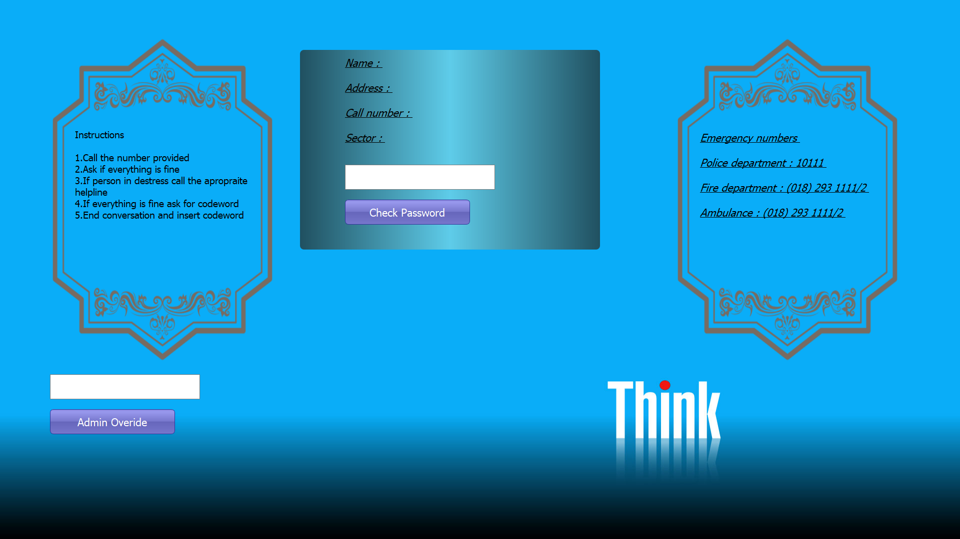

Figure : Incident display screen

### 5.2.7 Sub-system Test and Evaluation:

Table : Back-end Testing

|  |  |  |
| --- | --- | --- |
| Action | Expected Results | ✓/🗶 |
| Program started | Displays screen that cannot be exited can only navigate to admin login screen | ✓ |
| Login Pressed | When button is pressed navigate to admin login screen | ✓ |
| Incident occurs | If an incident occurs immediately open the incident window with no possibilities of closing it or going back | ✓ |
| Admin check login button pressed | Checks if admin user credentials are correct before giving him access to the database | ✓ |
| Admin Override pressed | Checks if admins override password is correct and if correct close incident | ✓ |
| Password check pressed | If the password typed in is the users correct passcode close the incident | ✓ |